SIMATS ENGINEERING
CO3- AT2 - Design Task - Medium
NAME: A. Gopi Raj
REG: 192412453
COURSE NAME: Advance Wireless Communication Systems /5G / 6G Communication Systems
COURSE CODE: ECA5604
24. Propose a channel reuse plan for multi-user wireless communication. (BL6)
Aim
To design a channel reuse plan that efficiently allocates wireless channels among multiple users while reducing interference.
Objectives
- To divide the coverage area into multiple cells.
- To allocate different frequency channels to neighboring cells.
- To reuse channels in non-adjacent cells.
- To improve spectrum utilization and network capacity.
- To simulate the channel allocation plan using MATLAB.
Pogram:
clc;
clear;
close all;

% Number of cells and users
N = 7;
usersPerCell = 2;

% Channel groups
channels = 1:N;

% Create cell-user allocation
disp('Channel Reuse Plan');
disp('------------------');

for cell = 1:N
fprintf('Cell %d -> Channel F%d -> Users U%d, U%d\n', ...
cell, channels(cell), ...
(cell-1)*usersPerCell+1, cell*usersPerCell);
end

% Plot channel reuse pattern
figure;
for cell = 1:N
theta = 2*pi*(cell-1)/N;
x = cos(theta);
y = sin(theta);

plot(x,y,'o','MarkerSize',20,'LineWidth',2);
hold on;
text(x,y,sprintf('Cell %d\nF%d',cell,channels(cell)), ...
'HorizontalAlignment','center');
end
axis equal;
grid on;
title('7-Cell Channel Reuse Plan');
xlabel('X Position');
ylabel('Y Position');

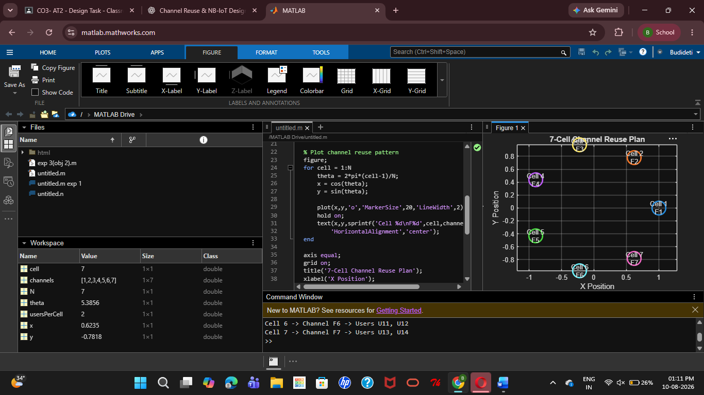
Result:
The channel reuse plan was successfully simulated in MATLAB, enabling efficient frequency allocation among multiple users while reducing interference and improving spectrum utilization.
25. Design an NB-IoT architecture for smart utility monitoring. (BL6)
Aim
To design an NB-IoT-based architecture for reliable and low-power monitoring of smart utility consumption.
Objectives
- To monitor electricity, water, or gas consumption.
- To transmit meter data using NB-IoT communication.
- To simulate utility data transmission using MATLAB.
- To enable remote monitoring of consumption.
- To improve energy efficiency and reduce manual meter reading.
PROGRAM
clc;
clear;
close all;

% Simulation parameters
T = 24; % 24 hours
time = 1:T;

% Simulated utility consumption
consumption = 2 + rand(1,T)*3;

% NB-IoT transmission
txData = consumption;

% Add small communication noise
rxData = txData + 0.05*randn(1,T);

% Display readings
disp('Smart Utility Monitoring using NB-IoT');
disp('--------------------------------------');

for i = 1:T
fprintf('Hour %02d : Consumption = %.2f units\n', ...
time(i), rxData(i));
end

% Plot monitoring data
figure;
plot(time,rxData,'-o','LineWidth',1.5);
grid on;
xlabel('Time (Hours)');
ylabel('Utility Consumption');
title('NB-IoT Smart Utility Monitoring');
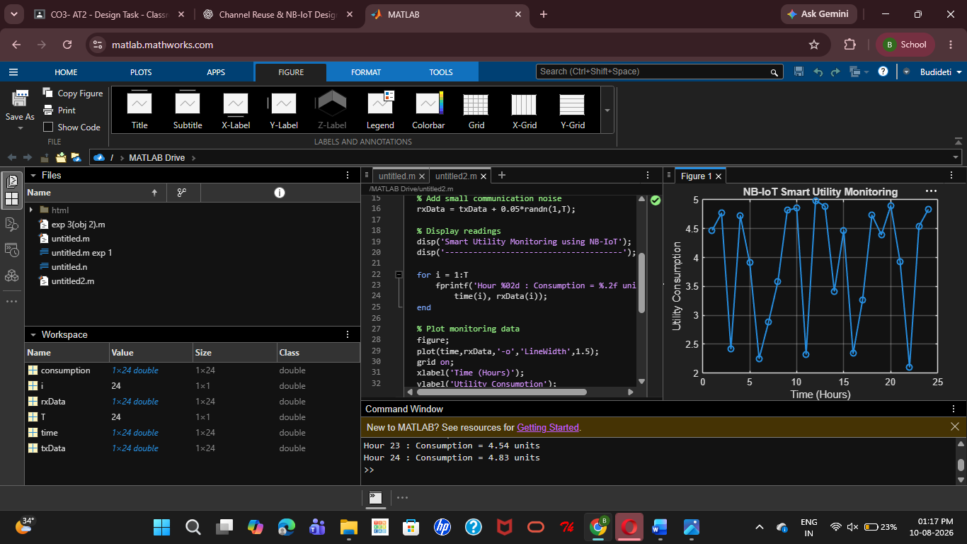
Result
The NB-IoT-based smart utility monitoring architecture was successfully simulated in MATLAB, enabling low-power data transmission and remote monitoring of utility consumption.

